Scenario 3: EBS Archive & Restore + Recycle Bin + Fast Snapshot Restore (FSR)
- EBS snapshots achieve –
    - you can move a snapshot to an “Archive tier” it is 75% cheaper.
    - Takes within 24 to 48 hours for restoring the archive.
    - Is meant for snapshots that you rarely need.
- Recycle bin for EBS snapshots –
    - Setup rule to retain deleted snapshots, so you can recover them after an accidental deletion.
    - Specify retention (from 1day to 1year)
- Fast snapshots restore –
    - Fast snapshots restore, but its costly.
- EBS snapshots achieve
Step 1: go to the EBS snapshots > right click the snapshot > click archiving.
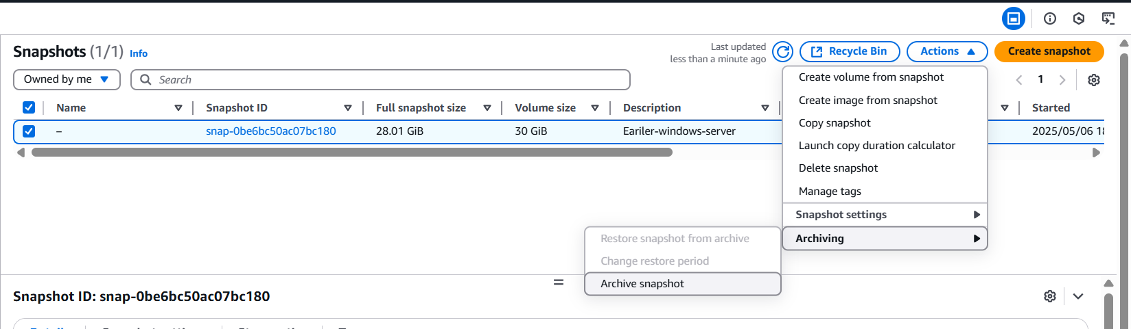
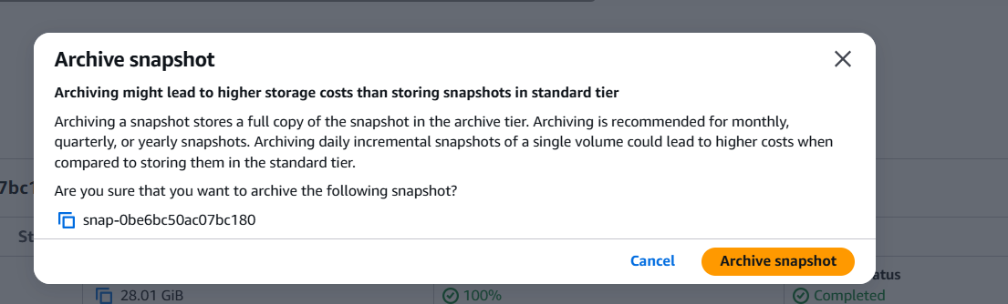
Step 2: you can validate the status of the archive under storage tier.
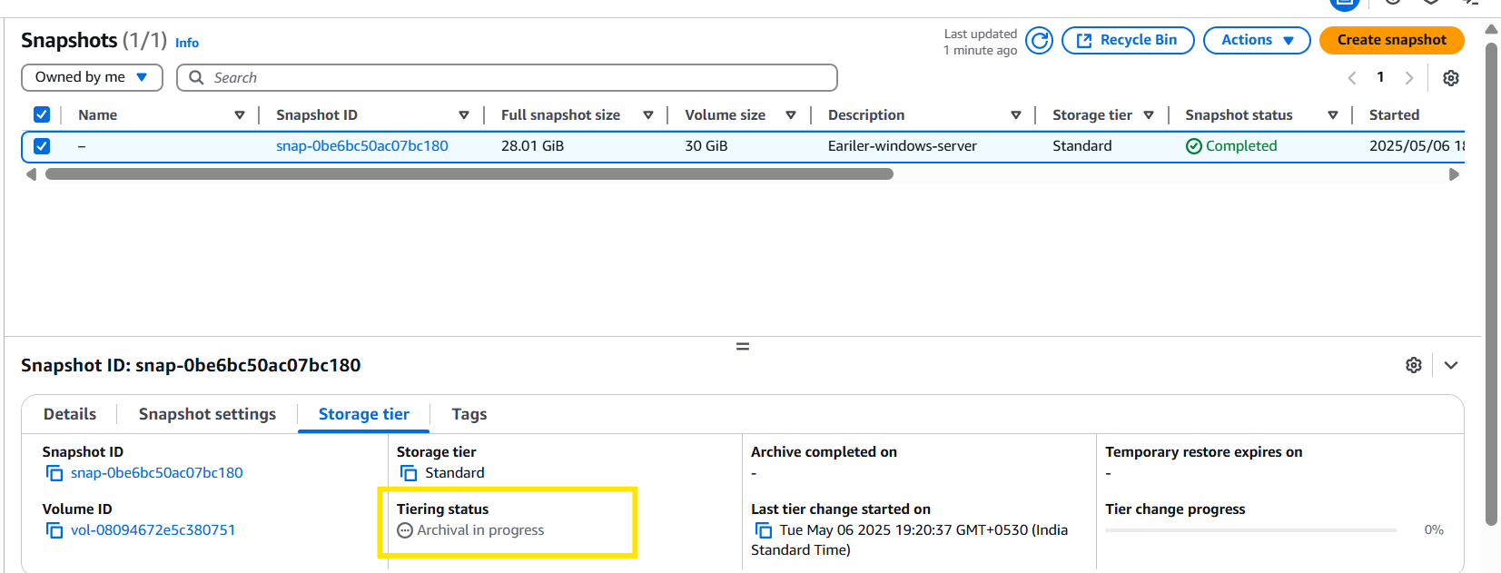
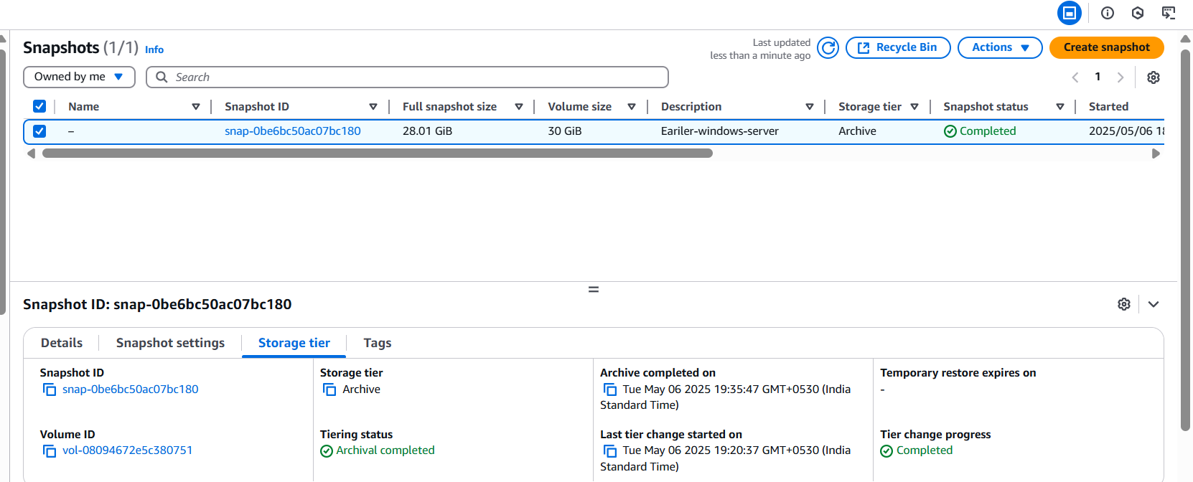
- Steps to Restore Archived Snapshot:
Restoring an archived snapshot moves it back to the Standard Tier, enabling you to create volumes from it.
Note: Restore time = 6 to 72 hours, depending on size

Step 1: Go to EC2 Console:

Open the EC2 Dashboard in the AWS Management Console.

Step 2: Navigate to Snapshots:

click "Snapshots" under Elastic Block Store.

Step 3: Select the Archived Snapshot:

Click the archived snapshot which you want to restore.
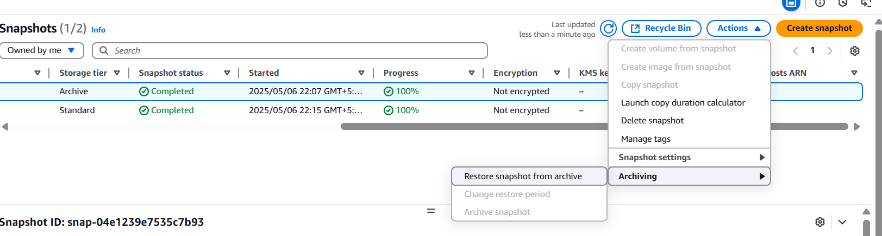

Step 4: Click on "Actions" > "Restore snapshot from archive":

Choose "Restore snapshot from archive"

Step 6: Confirm Restore:

AWS will begin restoring the snapshot to the standard tier.
This may take 6–72 hours depending on the snapshot size.

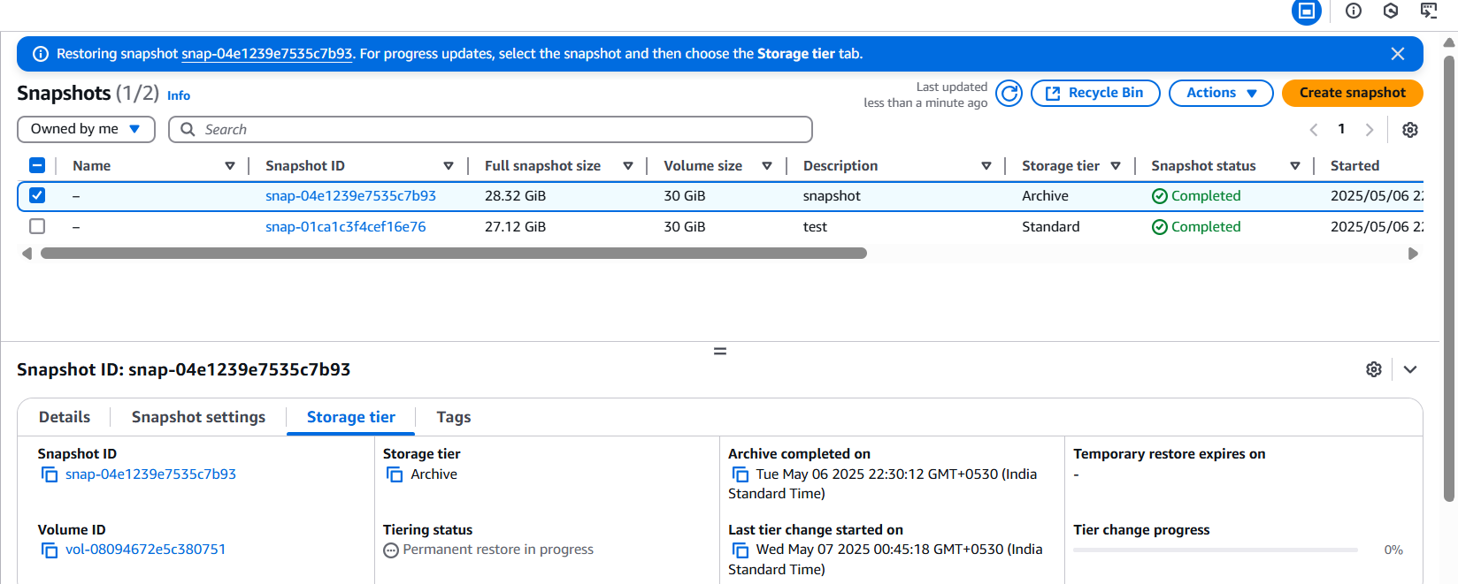

Step 7: Monitor Restore Progress:

The snapshot status will change from archived to restoring, and finally to available once ready.

- Fast snapshots restore
Fast Snapshot Restore (FSR) in AWS allows you to create EBS volumes from snapshots that are instantly usable — no initialization delay.
Note:
- FSR costs \$0.75 per AZ per snapshot per hour.
- You can disable FSR anytime to stop charges.
- Only works in the selected AZs.

Steps to Enable Fast Snapshot Restore:

Step 1: go to EC2 tab > Snapshots (under Elastic Block Store)

Step 2: Select the Snapshot you want to enable FSR on.

Step 3: Click Actions > Manage Fast Snapshot Restore
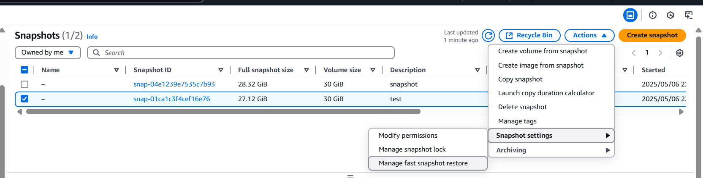

Step 4: Choose the Availability Zones where you want to enable it. Click Enable
From the image below I have selected the ap-south-1c and enabled it.

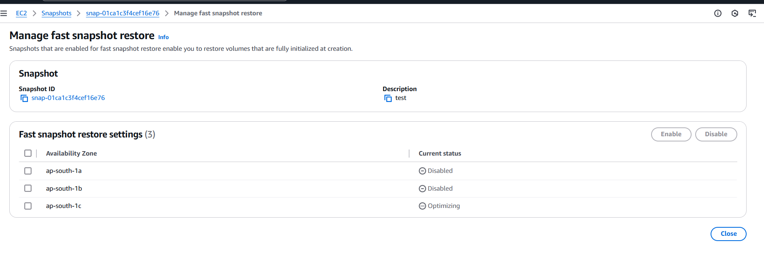
Step 5: To disable, follow the same step.
Now select the AZ which is in enabled and choose it as disable.
By this Fast snapshot restore will be disabled.
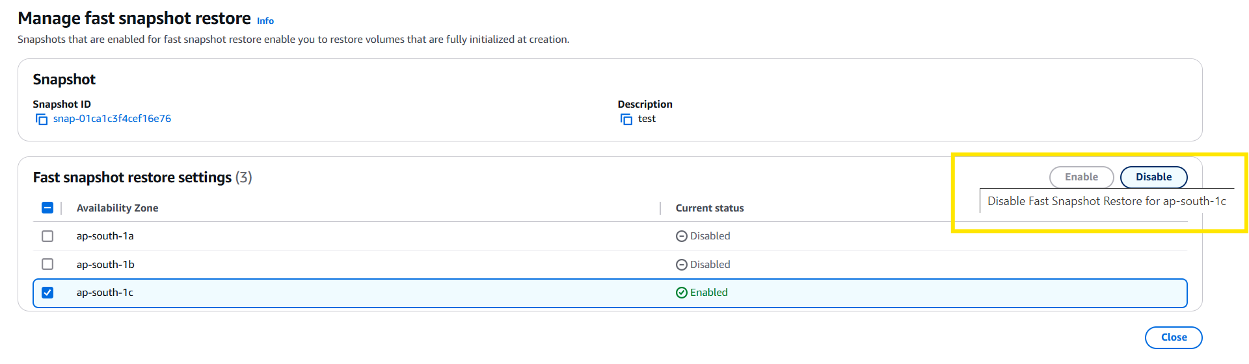
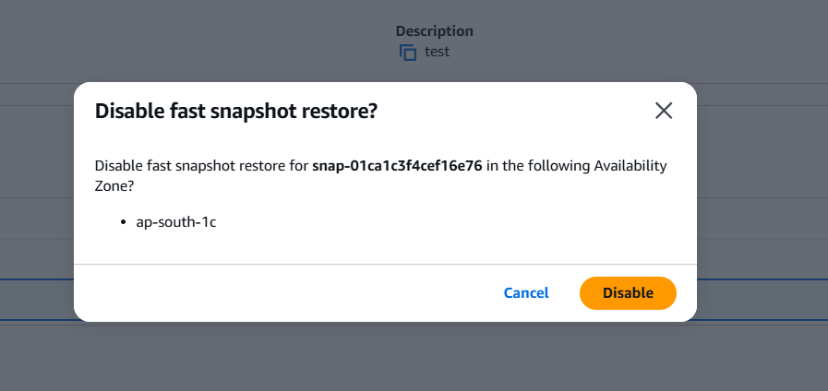

- Recycle bin for EBS snapshots

This feature protects against accidental deletions.
When a snapshot is deleted:
- It does not get removed permanently.
- It moves to the Recycle Bin.
- You can restore it anytime before the retention period ends

Step 1: search for recycle bin
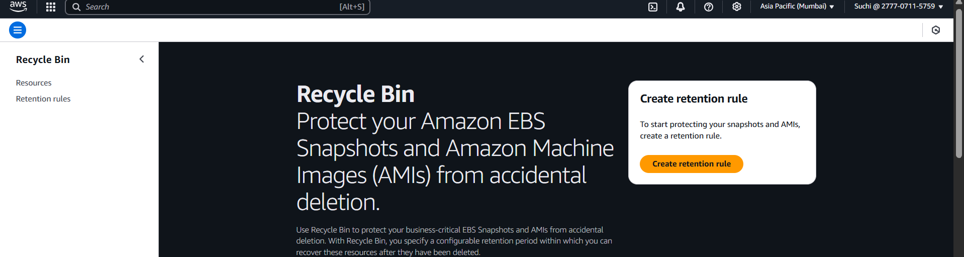
Step 2: create a retention rule.
Resource type -> EBS snapshots
Retention period -> example: 7days / 30 days/1year
Optional filters -> tags , resource IDs
Click create.

Now, any snapshot deleted will follow this retention rule.

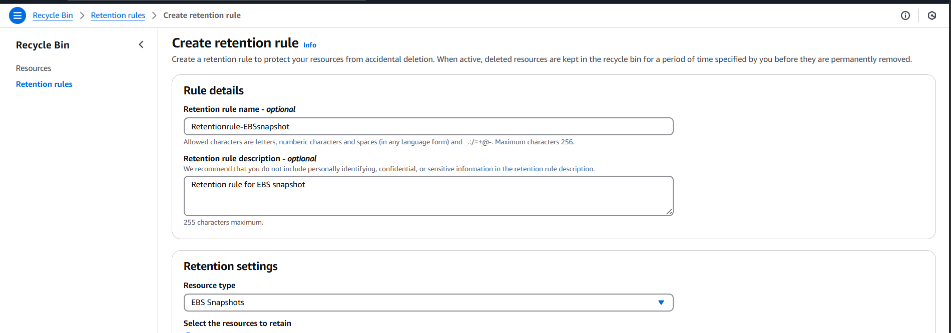
Step 3: to validate let’s delete the snapshots > right click delete.
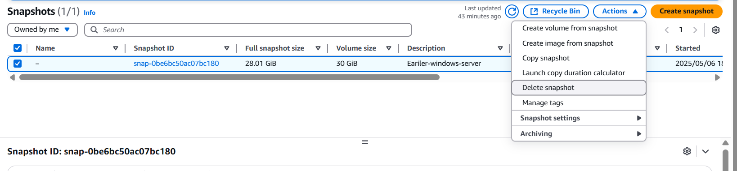
Step 4: Go to recycle you can see the snapshot here.
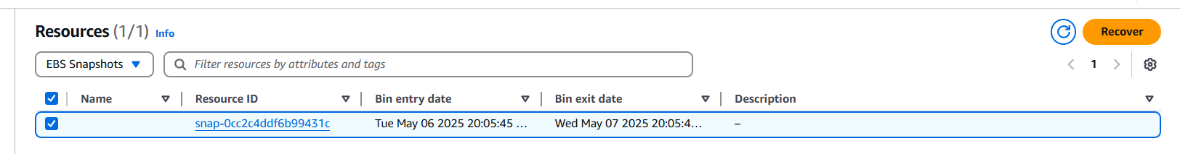
You can recover it by selecting it or else once the retention period is over it will be automatically deleted.

